[1]

**Exercise and Mixed Reality – Virtual Human**

Kiran C Shettar (Author), (M.Sc.,) Dept. of Computer Science  
University of Massachusetts, Lowell, MA, United States – 01851  
KShettar@cs.uml.edu

*Abstract*—During the 21st century, exercise and health are two main things that play major role in a human life. There are many different types of people in the real world. Some of them are obese who are are willing to exercise to become fit. We can also see several people who are normal but want to be fit to maintain a healthy life. In the medical field we know that physiotherapy is where many exercises are taught to patients to restore movement and function when someone is affected by injury, illness or disability. People can become fit by doing different types of exercise which is proven scientifically. Whereas, some people will be shy to go to the gym, some will have financial issues, some cannot afford personal trainers. People who need physiotherapy treatment may not be able to afford the medical expenses. All these issues can be solved by creating a virtual human that can train you anywhere, anytime just by learning how to use a Mixed Reality device. In this paper, I am presenting a mixed reality system that translates physical demonstration of various exercise protocols into movements which can be done by a holographic human.

# Introduction

Mixed reality is a rapidly expanding field. Fitness represents a tiny fraction of the AR effort, which focuses primarily on entertainment. We have all seen many exercise apps which demonstrates different types of exercise with human animation as shown in image – 1.

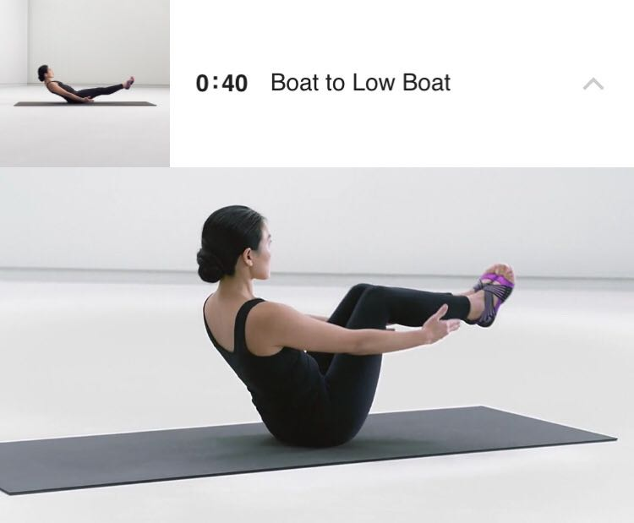  
 image – 1: Nike Training App

A mixed reality human (MRHs) hologram can be developed to perform different exercise actions like one mentioned in image - 1. This could be viewed with the Mobile AR technology or by wearing a physical HoloLens device in real time.

When it comes to the medical field, physiotherapy treatment is something that can be performed with two persons. The first person would be the patient and the second person would be the person who is helping the patient to perform different exercises. A research is being done on something similar like this. The recent research on medical team training with mixed reality humans (MRHs) has investigated how medical professionals speak up to MRHs [4], how medical professionals gaze at MRHs [5]. Some of the researches have also investigated how MRHs can influence communication skills during training [3]. MRHs can be developed as models with communication behavior.

# System description

## Implementation

The implementation of this system would be requiring the following devices/products and features:

* AR featured mobile device
* A rotating stand that holds the AR featured mobile device
* Open space to place a virtual human
* Mobile App with AR virtual human that has different exercise capabilities

## Description

The major part of the system is AR-based 3D hand gesture interface for all possible actions with the real-world objects. The other part would be designing virtual human object to perform many different actions or exercise. Using the hand gestures, the user can interact with the object like playing or pausing the actions whenever necessary. User can pull information by ‘grab’ and ‘place’ hand gestures where a new window would pop up and show the details of the exercise. The gestures being used in the system are like pointing, grabbing, dragging, resizing and dropping to interact with the virtual human object. For the hand gesture detection, an extension of Virtual Reality Framework is being used here. There would be a mobile app to perform these features that supports AR.



Image – 2: Profile settings - Training App

Once you launch the mobile app, you’ll be prompted to login with your social account (Google/Facebook). Then you will fill your details that would be necessary for the exercise. Some of the details that would be necessary could be age, height, weight, calories you would like to burn from the exercise which will decide the level of difficulty for exercise (Image - 2). Depending on the data we fill in the app, some of the featured exercises with a brief description would be shown to the user.

Once a user chooses which exercise to perform, a window will be launched with the camera feature open that would do the spatial mapping to analyze real-world objects. Here, the app will analyze the real-world objects in the room. A highlighted box is shown if there is a space available to place the virtual object that would perform the actions or exercise.

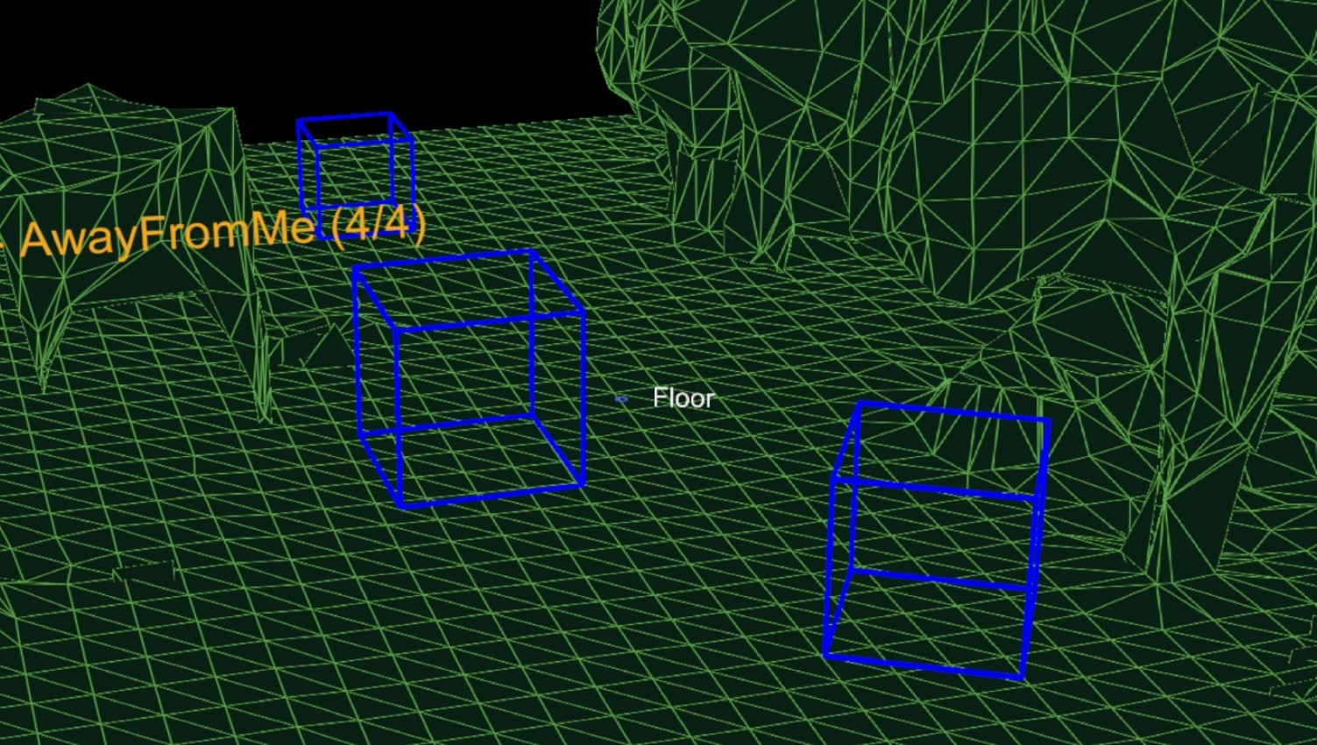

Image – 3: Spatial Mapping to place objects

Once the box is seen through the camera, you can place the mixed reality virtual human object using the tap gesture. A virtual human would be placed in the real-world space that has all the capabilities to perform the selected exercise. After the object is placed, an exercise can be paused/played by using ‘tap’ gesture. By performing ‘tap’ gesture on the info icon, the steps could be read from the user to perform the exercise in a mannered way. As the virtual object starts performing the exercise, a user can listen to the audio guide through-out the exercise. Audio guide can also be muted using the volume key on the AR capable mobile device.

## Demonstration

To demonstrate how a continuation between devices could look like, an AR capable mobile device is mounted to the movable stand. Height of the movable stand is recommended to be set to height of our eyes where you can view the screen of the mobile device without bending or raising your height.

Once, you choose the exercise, spatial mapping would be performed. The virtual human object must be placed in an open area. The stand could be moved closer or in any x-y-z direction to view the virtual human in all possible angles. The exercise can be performed by looking at the screen by keeping the stand constant after observing the steps of the exercise. A Bluetooth ear piece/ headphones/ speaker can be connected to the mobile device for the clarity of the voice from the exercise.

The User Interface for choosing the exercise would look something like the content shown in image - 4.

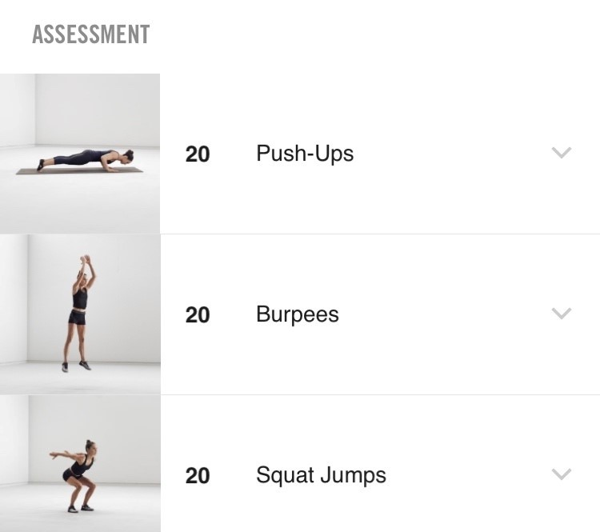

Image – 4: Exercise User Interface

# Conclusion and Future Work

Here we have presented the Mixed reality virtual human natural user interface concept that follows continuous user experience approach of connecting user and AR capable devices with real world objects. The major thing in our system is a 3D-gesture control interface for getting information from real world objects and the exercises that are available in the app designed. Virtual Reality Human is an extension of Mixed Reality natural user interface. By keeping the continuation, it helps user in keeping the complexity low.

Future work includes things like testing and implementing this system in the industries using multiple devices like HoloLens, Tablets, Computers and Tv. A connection could be created between multiple users/friends using the social account API’s where you can share your accomplishments and create challenges with each other. Some of the other future work in the app could be enhancing audio guide, improving the mixed reality human object design. To get better results, a long-term study is required. More gestures can be added to the system and can also be tested on different real-time spaces apart from a just a room. This process can be enhanced in future where the test will last longer.

# Acknowledgement

This paper was written as a part of Computer Graphics 2 course at the University of Massachusetts, Lowell, MA

# References

[1] Repeat after Me: Using Mixed Reality Humans to Influence Best

Communication Practices

[2] A. Kotranza, B. Lok, A. Deladisma, C. M. Pugh and D. S. Lind, "Mixed Reality Humans: Evaluating Behavior, Usability, and Acceptability," in IEEE Transactions on Visualization and Computer Graphics, vol. 15, no. 3, pp. 369-382, May-June 2009.

[3] A. Cordar, A. Robb, A. Wendling, S. Lampotang, C. White, and

B. Lok. Virtual role-models: Using virtual humans to train best

communication practices for healthcare teams. In Intelligent Virtual

Agents, pages 229–238. Springer, 2015.

[4] A. Robb, C. White, A. Cordar, A. Wendling, S. Lampotang, and

B. Lok. A Qualitative Evaluation of Behavior during Conflict with

an Authoritative Virtual Human. In Intelligent Virtual Agents, pages

397–409, 2014.

[5] A. Robb, A. Kleinsmith, A. Cordar, C. White, S. Lampotang,

A. Wendling, and B. Lok. Do variations in agency indirectly affect

behavior with others? an analysis of gaze behavior. IEEE transactions

on visualization and computer graphics, 22(4):1336–1345, 2016.

[6] <https://www.nike.com/us/en_us/c/nike-plus/training-app>

1.